**PRACTICUM REPORT**

**ALGORITHM AND PROGRAMMING**

**7TH MEETING**



**Written By :**

|  |  |
| --- | --- |
| **NAME** | **: NANANG SETYAWAN** |
| **NIM** | **: 185410025** |
| **MAJOR** | **: INFORMATICS ENGINEERING** |
| **DEGREE** | **: S1** |

**STMIK AKAKOM**

**YOGYAKARTA**

**2018**

# **PRACTICUM REPORTALGORITHM DAN PROGRAMMING** 7TH MEETING

1. **PURPOSE**

* Student can write using control switch structure
* Student can compare if/else construction with control switch structure
* Student explain using keyword break purpose
* Student can explain standard component in for loop
* Student can make and use for loop
* Student can explain scope variable

1. **LISTING**

**1st Practice**

1. **Using if else structure**

import java.util.Scanner;

public class GradeIf{

public static void main(String[]args){

Scanner in= new Scanner(System.in);

System.out.print("Enter your grade :");

int grade= in.nextInt();

if(grade==9){

System.out.println("you are a freshman");

}

else if (grade== 10){

System.out.println("You are a sophomore");

}

else if (grade== 11){

System.out.println("You are a junior");

}

else if (grade== 12){

System.out.println("You are a senior");

}

else{

System.out.println("Invalid grade");

}

}

}

Output :

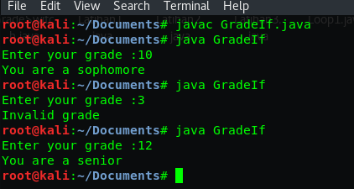

Explanation :

In this code we will input keyboard in output because the method using import java.util.Scanner

In this code also we will still using if/else method because we will compare it with switch/case method in next codes. I will explain those codes means

In codes above the statement is grade ==9

1st If the statement true the output will show(“You are a freshman”), but

2nd If the first condition is false and grade ==10 the output will show (“You are a sophomore”)

3rd If grade ==11 the output will show (“You are a junior”) and

4th If grade ==12 the output will show (“You are a senior”) but

5th If all those condition is false the output will show (Invalid grade)

Lets look at output picture above. We input 10 and automatically 2nd condition is true and its output will show (“You are a sophomore”). we input 3 and the 5th condition is true and we input 12 so the 4th condition is true

1. **Using switch structure**

import java.util.Scanner;

public class GradeSwitch{

public static void main(String[]args){

Scanner in= new Scanner(System.in);

System.out.println("Enter your grade ?");

int grade= in.nextInt();

switch (grade){

case 9:

System.out.println("You are freshman");

break;

case 10:

System.out.println("You are sophomore");

break;

case 11:

System.out.println("You are a junior");

break;

case 12:

System.out.println("You are a senior");

break;

default:

System.out.println("Invalid grade");

}

}

}

Output :

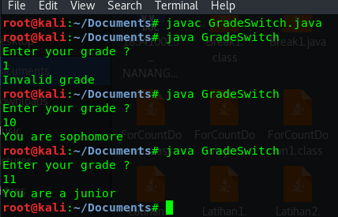

Explanation :

This codes is similiar with previous codes but the different is in previous codes we use if/else method but in this codes we use switch/case method. The different between if/else method and swith case method is if/else method can use logic operator (<, >, <=, >=) but switch case we use String or integer.

Break used to end statement each condition.

We can see at codes above, switch (grade) its mean we will see the condition according to grade

1st case 9 is the first condition that if this condition is true the output is (“You are a freshman”)

2nd case 10 is the second condition, if this true the output is (“You are sophomore”)

3rd case 11 is third condition, if this is true the output is (“You are a junior”)

4th case 12 is fourth condition, if this true the output is (“You are a senior”)

5th default is like else function. If all the condition above is false, we this condition is true and the output is (“Invalid grade”).

At the output above we input 1 and 5th condition is true, we input 10 and 2nd condition is true, we input 11 and 3rd condition is true. So the output of each true condition will be shown

**2nd Practice**

1. **Int type**

import java.util.Scanner;

public class DaysMonth{

public static void main(String[]args){

Scanner in= new Scanner(System.in);

System.out.print("Enter your number of month: ");

int month= in.nextInt();

switch (month){

case 1: case 3: case 5: case 7:

case 8: case 10: case 12:

System.out.println("31 days in a month");

break;

case 2:

System.out.println("not leap year 28 days in the month");

System.out.println("leap year 29 days in the month");

break;

default:

System.out.println("30 days in a month");

}

}

}

Output :

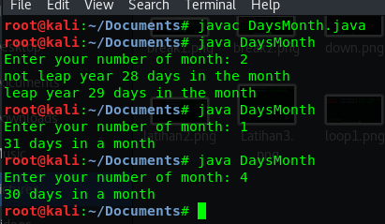

Explanation :

This code is little similiar with previous code but in previous codes we use grade variable and in this code we use month variable. So lets see the condition

1st case 1,case 3, case 5, case 7, case 8, case 10, case 12, if the number we input is 1,3,5,7,8,10 and 12 1st condition is true and its output will show ("31 days in the month")

2nd case 2, if we input number 2 this condition is true and will show output ("not leap year 28 days in the month") and ("leap year 29 days in the month")

3rd default, if we input the number except the number in condition before(1,2,3,5,7,8,10,12) this condition will true. Its mean if we input (4,6,9 and 11) this condition is true and will show output (30 days in a month)

1. **String type**

public class TypeOfDay{

public static void main(String[]args){

String typeOfDay= "";

String dayOfWeekArg= "Thursday";

switch (dayOfWeekArg){

case "Monday":

typeOfDay= "Start of work week";

break;

case"Tuesday":

case "Wednesday":

case "Thursday":

typeOfDay= "Midweek";

break;

case "Friday":

typeOfDay= "End of work week";

break;

default:

System.out.println("Invalid");

}

System.out.println(typeOfDay);

}

}

Output :

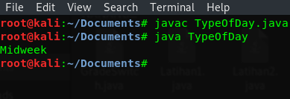

Explanation :

In this code we not using import java.util.Scanner so when we compile and run this codes the ouput will be showed without input keyboard

In this case we have switch with dayOfWeekArg and we know from the codes above that dayOfWeekArg values is “Thursday”, so let see the condition

We will know first that the output is typeOfDay variable, so we will search the true typeOfVariable.

We use double quotation mark for value of dayOfWeekArg because its a String data type,

If we use int data type we dont use a mark and for char data type we use one quotation mark

1st case “Monday”, if this case is true the output is “Start of work week”

2nd case “Tuesday”,” Wednesdey”, “Thursday”, if one this case condition is true the output is “Midweek”

3rd case Friday, if this condition true the output is “End of work week”

4th default, if all the previous condition is false, this condition will be true and the output is “Invalid”

We can see the codes before condition that dayOfWeekArg : “Thursday”, so the 2nd condition is true because one of 3 case is true and the output is “Midweek” same with ouput picture above

**3rd Practice**

1. **With break**

public class Break1{

public static void main(String[]args){

char option= 'A';

int aCount= 0, bCount= 0, cCount= 0;

switch (option){

case 'A':

aCount++;

System.out.println("Count of A" + aCount);

break;

case 'B':

bCount++;

System.out.println("Count of B" + bCount);

break;

case 'C':

cCount++;

System.out.println("Count of C" + cCount);

}

}

}

Output :

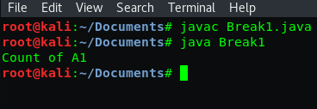

Explanation :

In this code we will use switch case method with char data type. The differences char data type from others data type is in char we use one quotation mark(‘) for value of the variable in each case or in each condition. Example for this codes the variable is option and the char option is ‘A’

In here codes there are 3 condition case ‘A’, ‘B’, and ‘C’. because the char option above is ‘A’ so the first case or condition si true and its output is (Count of A1). count of A is constant that write in output and 1 is come from aCount++ which is aCount value is 0+1 = 1 and we combine into (Count of A1)

1. **Without break**

public class Break2{

public static void main(String[]args){

char option= 'A';

int aCount= 0, bCount= 0, cCount= 0;

switch (option){

case 'A':

aCount++;

System.out.println("Count of A" + aCount);

case 'B':

bCount++;

System.out.println("Count of B" + bCount);

case 'C':

cCount++;

System.out.println("Count of C" + cCount);

}

}

}

Output :

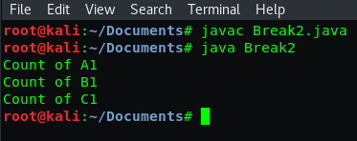

Expalantion :

This codes is same with previous codes but in this codes we will check a conditon or case without break command. We will see what happen in this 3 condition without break command to compare it. Here we use char data type and we must put a one quotation mark(‘) on the valuie of option variable. Example ‘A’, ‘B’ and ‘C’

According to output, it show all the output of each condition. Why?

Because break command used to stop the condition and continue to check other condition but without it the all condition combined and showed at the output.

1. **Fall through**

public class FallThrough{

public static void main(String[]args){

int month= 12;

switch(month){

case 2:

System.out.println("28 days(29 in leap years)");

break;

case 4:

case 6:

case 9:

case 11:

System.out.println("30 days");

break;

case 1:

case 3:

case 5:

case 7:

case 8:

case 12:

System.out.println("31 days");

break;

default:

System.out.println("Illegal month number");

break;

}

}

}

Output :

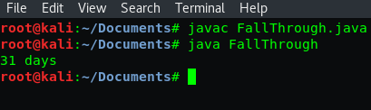

Explanation :

In this code we use month variable with four condition.

This codes is little different from others codes because we will use fallthrough method

Fallthrough method used to force the checking process till reach the break command

For example from case 4 to case 11 its has same output and stopped by break command and continue to next condition case 1 till case 12 and stopped with break.

So every break command will stop every condition. Thats why without break all the condition will be show at output. In output above the output is 31 days because month =12 so the true condition is 12. even the true condition is 1,3,5 or 7 the output will show 31 days because it in same case and not divided by break command

**4th Practice**

1. **Count down**

public class CountDown{

public static void main(String[]args){

System.out.println("CountDown to Launch");

System.out.println(10);

System.out.println(9);

System.out.println(8);

System.out.println(7);

System.out.println(6);

System.out.println(5);

System.out.println(4);

System.out.println(3);

System.out.println(2);

System.out.println(1);

System.out.println("Blast off!");

}

}

Output :

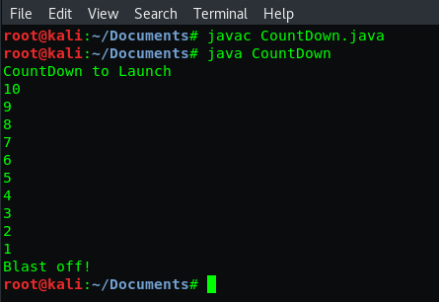

Explanation :

This codes is not too hard to understand. There is not condition, there is no loop, switch or if/else method. We just write the System.out.println directly and show the output according to the command. And the command asked us to cuntdown from 10 till 1

Thats why we manually write the number from 10 to 1 and Blast off! To end it

Its all according to the output and the codes.

1. **Using help Variable**

public class CountDown1{

public static void main(String[]args){

int i= 10;

System.out.println("CountDown to Launch");

System.out.println(i);

i--;

System.out.println(i);

i--;

System.out.println(i);

i--;

System.out.println(i);

i--;

System.out.println(i);

i--;

System.out.println(i);

i--;

System.out.println(i);

i--;

System.out.println(i);

i--;

System.out.println(i);

i--;

System.out.println(i);

System.out.println("Blast off!");

}

}

Output :

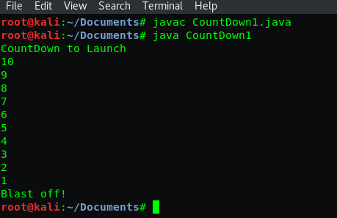

Explanation :

This code is has same output with previous codes but its has different way to write a codes

In codes above we has variable i with value = 10, so if in the output show variable i the output must be 10. at the first output line it write (“CountDown to Launch”) so its wrote at first in output. Second output line in the codes is (i) so the output must be 10 and it same with teh second line in output picture. Third output line is still (i) but with i--, so the value we substract by 1 (10-1). thats why third line is 9 and for other line its always substract by 1 each output because all in the codes use i--

**5th Practice**

1. **Count down with for**

public class ForCountDown{

public static void main(String[]args){

System.out.println("CountDown");

for (int i=10;i>=0;i--){

System.out.println(i);

}

System.out.println("Blast off!");

}

}

Output :

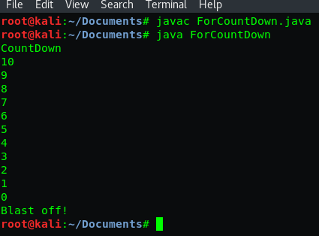

Expalantion :

In this codes we asked to Countdown from 10 to 0 start with CountDown and end it with Blast off!. but in this code we use for loop and we dont need to write a long codes with many output

For loop is the easiest method to write a loop, so i will explain the codes.

For the CountDown output and Blast off! We input it manually in the System.out.println

Int i=10, int is a data type, i is variable and 10 is its value

i >=0 = its mean 10 is bigger or same with 0, so the loop is until 0

i-- = its mean we must substract 10 by 1 each line till reach 0

Thats why the output is 10 till 0 which each line subtract by 1

1. **Condition expression**

public class ForCountDown1{

public static void main(String[]args){

System.out.println("CountDown");

for (int i=10;i>0;i--){

System.out.println(i);

}

System.out.println("Blast off!");

}

}

Output :

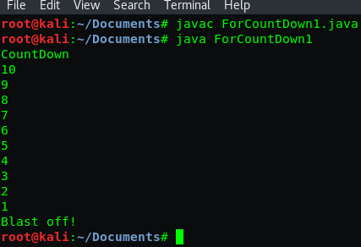

Explanation :

This code is exactly same with previous code but the the different is in this code we will do a loop from 10 to 1 and in the previous code we loop from 10 to 0. lets see the differences

Int i=10, int is a data type, i is variable and 10 is its value

i >0 = its mean 10 is bigger than 0, so the loop just till bigger than 0. its mean till 1

i-- = its mean we must substract 10 by 1 each line till reach 1

The different is > and >= bigger and bigger or same

If we use >= it will loop till the number that write in the code

If we use > it will loop till the bigger from the number wrote in the code

1. **Update expression**

public class ForCountDown2{

public static void main(String[]args){

System.out.println("CountDown");

for (int i=10;i>=0;i=i-2){

System.out.println(i);

}

System.out.println("Blast off!");

}

}

Output :

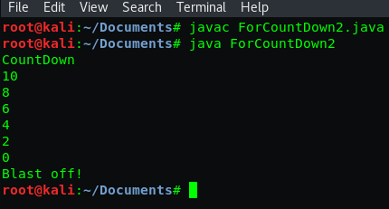

Explanation :

In this codes we still using loop for and we will countdown from 10 to 0 but with 2 interval number. In previous codes we using for loop but with 1 interval number

I will explain what the codes mean

Int i=10, int is a data type, i is variable and 10 is its value

i >=0 = its mean 10 is bigger or same with 0, so the loop is until 0

i= i-2 its mean we must substract 10 by 2 each line till reach 0

Thats why the output is 10,8,6,4,2,0 because i-2 its mean the interval each number is 2

1. **Alternative update expression write**

public class ForCountDown3{

public static void main(String[]args){

System.out.println("CountDown");

for (int i=10;i>=0;){

System.out.println(i);

i--;

}

System.out.println("Blast off!");

}

}

Output :

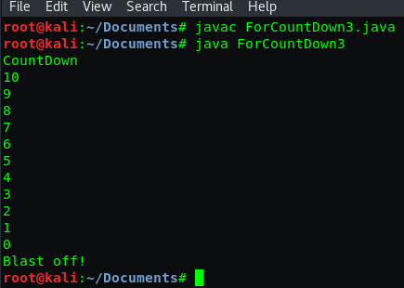

Explanation :

This codes still using a for loop method same with previous code but in different way

In this code we use for loop after System.out.println or after output command

We use i-- its mean we substract the value with 1 and the interval each line will be 1

We do a loop till 0 because i >=0 and i value is 10

So 10 substract by 1 till 0. same with code before but the differences is where we write i-- for looping.

1. **Multiple statement**

public class Loop1{

public static void main(String[]args){

for (int i=5;i>0;i--)

System.out.println(i);

System.out.println("second line");

}

}

Output :

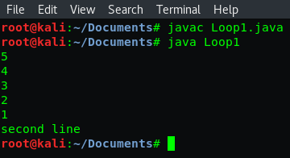

Explanation :

This is the other codes using for loop method but the variable value is different from code before. We will doing loop from 5 till 1 and end it with second line output

Int i=5, beacuse the value is 5 we will start looping from number 5

i >0, its mean we doing looping from 5 to 1. we dont use 0 because the command is bigger than 0, so 1 is right number

i--, its mean i will be substract by 1 so 5-1 and next till we get number 1. because it subtract by 1 the intervel each number is 1. same with the output picture above

**6th Practice**

1. **Looping without loop**

public class Squared1{

public static void main(String[]args){

System.out.println("1 squared= " + 1*1);

System.out.println("2 squared= " + 2*2);

System.out.println("3 squared= " + 3*3);

System.out.println("4 squared= " + 4*4);

System.out.println("5 squared= " + 5*5);

}

}

Output :

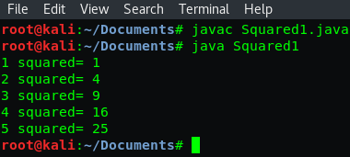

Explanation :

In this code we will use squared for the output

We write the output manually and we will add it with squared number

At codes above we see at the first line is 1*1 =1 so the first output line is “1 squared= 1”

Second output 2*2 =4 so the output is “2 squared= 4”

Third output 3*3 =9 so the output is “3 squared= 9”

Fourth output 4*4 =16 so the output is “4 squared= 16”

Fifth output 5*5 =25 so the output is “5 squared= 25”

1. **looping with loop for**

public class Squared2{

public static void main(String[]args){

for (int i=0;i<=20;i+=2){

System.out.println(i);

}

}

}

Output :

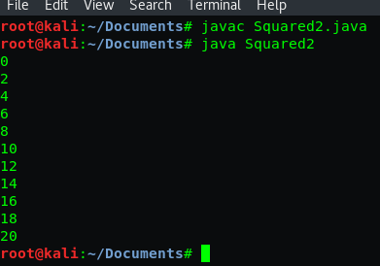

Explanation :

In this code we will using for loop again but with different value and interval number

I will explain the codes means

Int i=0, beacuse the value is 0 we will start looping from number 0

i <=20, its mean we doing looping from 0 to 20

i+=2, its mean i will be add by 2, 0+2= 2 and we will continue it till number 20

Because we add it by 2 so the number interval is 2

Thats why the output is 0,2,4,6,8,10,12,14,16,18,20. all of it has 2 number interval

1. **Using I variable**

public class Squared3{

public static void main(String[]args){

for (int i=1;i<=5;i++){

System.out.println(i+" squared= "+ i*i);

System.out.println("i: "+i);

}

}

}

Output :

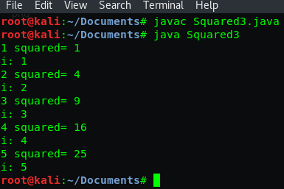

Explanation :

In this code we will combine 2 method to run the program

In this code we use for loop and squared method. So the looping number will be shown and we will search the squared from the number that shown from looping. Lets explain

Int i=1, beacuse the value is 1 we will start looping from number 1

i <=5, its mean we doing looping from 1 to 5

i++, its mean i will be add by 1, 1+1= 2 and we will continue it till number 5

Because we add it by 1 so the number interval is 1

The output must be 1,2,3,4,5 but we will search the squared from each number

1*1=1, 2*2=4, 3*3=9, 4*4=16, 5*5=25 so the squared is 1,4,9,16,25

1. **Scope variable**

public class Scope1{

public static void main(String[]args){

int x= 0;

int i= 1;

for (int j=2;j<=5;j++){

System.out.println(j);

int k= 3;

System.out.println(x+i+j+k);

}

}

}

Output :

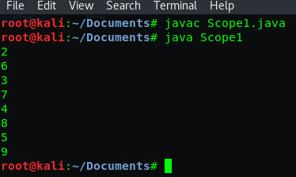

Explanation:

In this code we still use for loop method but with little modification. We added new variable except the first variable. So i will explain for first variable

Int x=0, so the value of x is 0

Int i=1, so the value of x is 1

Int j=2, beacuse the value is 2 we will start looping from number 2

j <=5, its mean we doing looping from 2 to 5

j++, its mean i will be add by 1. so we will know the output which is 2,3,4,5 but why there is 6,7,8,9 between them. Because of second variable

Int k=3 and output is x+i+j+k which means 0+1+2+3 =6 and it will start from 6 and add it by 1 in three times. It three times because we need three times adding from 2 to 5

1. **Out of Scope**

public class Scope2{

public static void main(String[]args){

for (int j=0;j<=5;j++){

System.out.print(j+" ");

}

for (int j=5;j>=0;j--){

System.out.print(j+" ");

}

for (int k=2;k<=64;k=k+2){

System.out.print(k+" ");

}

}

}

Output :



Explanation :

In this code we use for loop method with three times for looping

First output:

Int j=0, beacuse the value is 0 we will start looping from number 0

j <=5, its mean we doing looping from 0 to 5

j++, its mean i will be add i by 1. so the interval number is 1

So the output is 0,1,2,3,4,5

Second ouput:

Int j=5, beacuse the value is 5 we will start looping from number 5

j >=5, its mean we doing looping from 5 to 0

j--, its mean i will be substract i by 1. so the interval number is 1

So the output is 5,4,3,2,1,0

Third output:

Int k=2, beacuse the value is 2 we will start looping from number 2

k <=64, its mean we doing looping from 2 to 64

k=+2, its mean i will be add by 1. so the interval number is 2

And the output is 2,4,6,8,10,12,14,16,18 and always add by 2 until 64

1. **EXERCISE**
2. **Switch case**

import java.util.Scanner;

public class Latihan1{

public static void main(String[]args){

Scanner sc= new Scanner(System.in);

System.out.print("Masukkan nomor bulan : ");

int bulan= sc.nextInt();

switch(bulan){

case 1:

System.out.println("Januari");

break;

case 2:

System.out.println("Februari");

break;

case 3:

System.out.println("Maret");

break;

case 4:

System.out.println("April");

break;

case 5:

System.out.println("Mei");

break;

case 6:

System.out.println("Juni");

break;

case 7:

System.out.println("Juli");

break;

case 8:

System.out.println("Agustus");

break;

case 9:

System.out.println("September");

break;

case 10:

System.out.println("Oktober");

break;

case 11:

System.out.println("November");

break;

case 12:

System.out.println("Desember");

break;

default:

System.out.println("Invalid month");

}

}

}

Output :

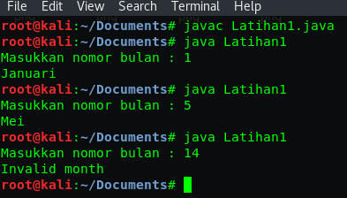

Explanation:

In this code we use Switch case method with the variable is month

In this case we input a case number according to the month. For example we use case 1 for januari and case 2 for februari. So we will know when we input 10 the output must be Oktober, we input 5 and the output is 5 but when we input number except the number of month, for example we input 14 which is the month just till 12 the output is Invalid month

1. **Loop 0 till 5**

public class Latihan2{

public static void main(String[]args){

for(int i=0;i<=5;i++){

System.out.println(i);

}

}

}

Output :

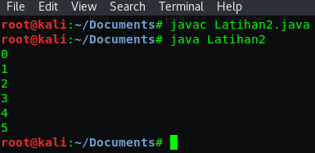

Explanation :

This code is same with many code in the practice before and i will explain again

Int i=0, so we will start looping from 0

i <=5, its mean 0 is smaller or same with 5

i++, its mean we added i with 1 or the interval number is 1

So the looping is 0, 0+1=1, 1+1=2, 2+1=3, 3+1=4, 4+1=5

And the output is 0,1,2,3,4,5

1. **Loop even 0 till 20**

public class Latihan3{

public static void main(String[]args){

for(int i=0;i<=20;i=i+2){

System.out.println(i);

}

}

}

Output :

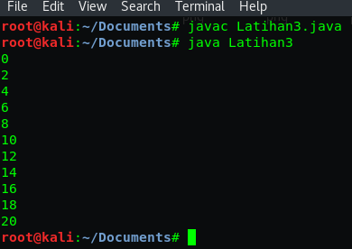

Explanation :

This codes is same with code before but has a different value and different interval, so i will explain it by its value and interval

Int i=0, so we will start looping from 0

i <=20, its mean 0 is smaller or same with 20

i=i+2, its mean we added i with 2 or the interval number is 2

So the looping is 0, 0+2=2, 2+2=4, 4+2=6, 6+2=8, 8+2=10 and continue like that till get number 20.

And the output is 0,2,4,6,8,10,12,14,16,18,20

1. **conclution**

In this practicum we learn about switch case, for loop and its different way to write the codes

In this practicum also we can compare and we can know the different between Switch method and if/else method

Switch cant use to compare two or more statement but Switch is usefull if we get a code with many condition

If else not recomended for write in many condition code but if/else is the most used method in writing a program.

For loop used to made looping between number. Not just for but there are many loop method for example while and while do. But its function or written code method not too different with for method